Evaluating habitat change of the red panda (*Ailurus Fulgens*) from 2000 – 2018

# Summary

Habitat loss has consistently been identified as the largest threat facing the endangered red panda. The species’ low dispersal capabilities, arboreal lifestyle, and narrow distribution also make red pandas particularly susceptible to reproductive isolation cause by habitat fragmentation. For the first time, this dissertation quantifies the extent of habitat loss across the red pandas entire range, and maps the areas of low and high habitat disturbance. My results estimate an area of XXX km2 of forest habitat has been lost since 2000 - 2018. The XXX area and the YYY area show the most pronounced forest loss. No countries show a net increase in forest from 2000 - 2012 in red panda habitat. Protected areas sufficiently/insufficiently protect forest. Habitats at lower elevation show the highest amount of habitat loss, which correlates with higher human population. The forest network in red panda habitat is likely fragmented into 3 isolated populations, with X habitat bottlenecks experiencing moderate to high disturbance. The conservation implications of this work are…

Table of Contents

Summary 2

Contents Page 3

1. Introduction 5

1.1 The red panda 5

Ecology 5

Two species or one? 5

Threats and current conservation efforts 5

1.3 Project Rationale 5

A remote sensing approach 5

Towards a range wide conservation plan for red pandas 5

1.4 Research questions and hypotheses 5

RQ1 What change has occurred to forests in red panda habitat? 6

2. Methods 7

2.1 Defining the study area 7

2.2 Data collection 7

Global Forest Change Dataset 7

Red Panda distrubution 7

2.3 Data processing 7

Forest Change 7

Hot spot identification 7

2.4 Data analysis 7

Contents Page

Summary

Table of contents

Acknowledgements

List of abbreviations

1. Introduction

* 1.1 Red panda ecology
  + Two species or one?
* 1.2 Threats and current conservation efforts
  + Remote sensing tools
* 1.3 Project Rationale
* 1.4 Research questions and hypotheses

2. Methods

* 2.1 Defining the study area
* 2.2 Data collection
  + Global Forest Change Dataset
  + Red Panda MaxEnt distrubution
* 2.3 Data processing
  + Forest Change
  + Hot spot identification
* 2.4 Data analysis

3. Results

* How forest cover has changed in predicted red panda habitat from 2000-2018
* Protected areas and habitat loss
* Key areas of habitat loss

4. Discussion

* How is Red Panda Habitat changing?
* Conservation implications
* Limitations
* Future work

1. Introduction

The world is experiencing massive ecosystem change.

Terrestrial mammal populations are changing rapidly around the world. Both population increases and decreases have been exacerbated by human activity. Habitat change and fragmentation represent the primary drivers of population change. Species with narrowly defined niches and low dispersal capabilities often respond poorly to these drivers and show the most significant declines. Such as the red panda.

1.1 The red panda

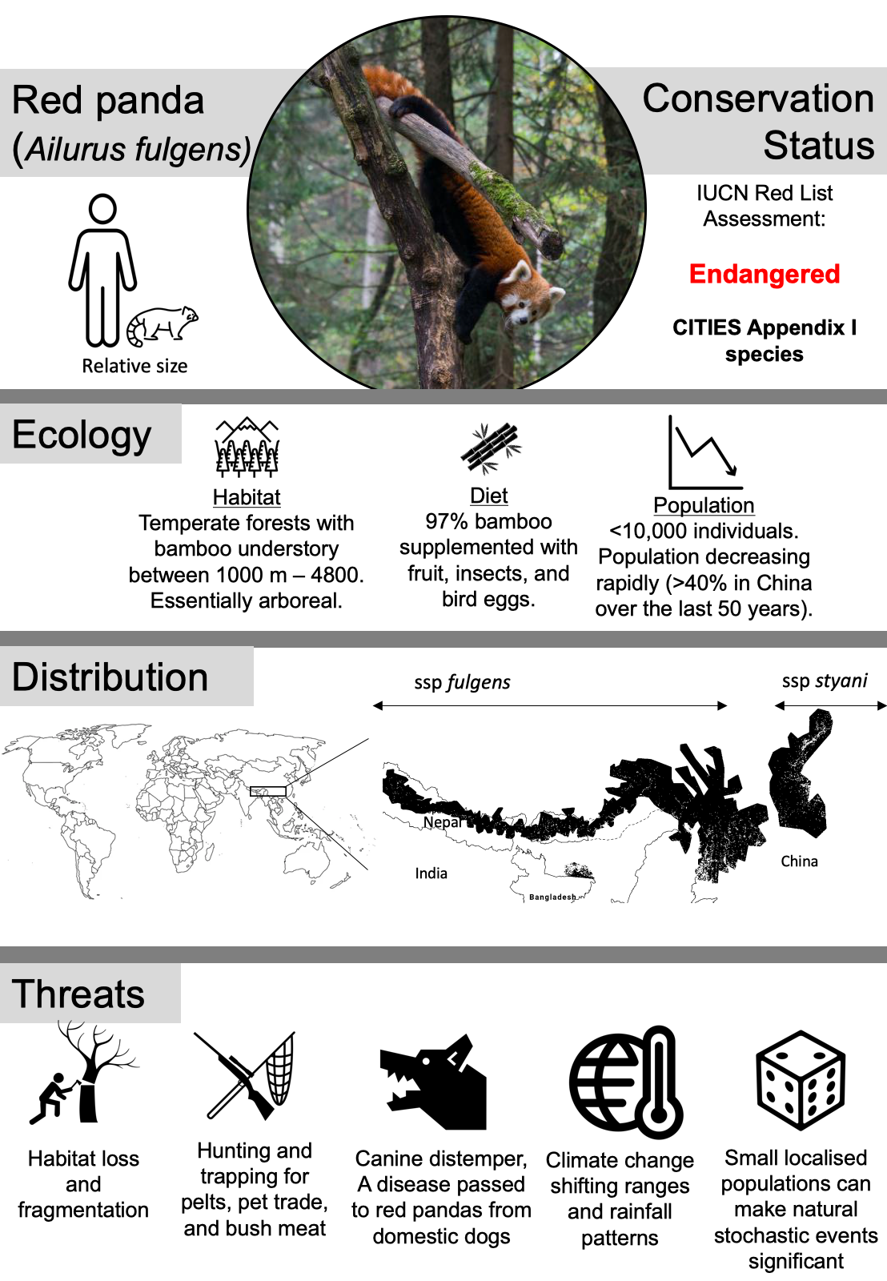

Figure 1: Red pandas at a glance.

Ecology

Red pandas are exacting in their habitat requirements.

Two species or one?

Two genetically distinct populations of red pandas exist. Separated by X river valley. Previously considered a sub species, genetic analysis now suggests they are two distinct species. This taxonomic view is still debated. Slitting the species will have conservation implications and as such I have made a distinction between the two sub species in this dissertation

Threats and current conservation efforts

1.3 Project Rationale

A remote sensing approach

Towards a range wide conservation plan for red pandas

1.4 Research questions and hypotheses

RQ1 What change has occurred to forests in red panda habitat?

Deforestation is reportedly occurring across the range of the red panda and is stated as one of the most prominent threats to red pandas. Due to the emphasis put on this threat in the literature I expect a sizable about of forest to have been lost across this entire range. The value of 10% has been chosen arbitrarily to represent a sizable amount of loss. I also expect the rate of forest loss to be increasing as the human population in increasing in red panda habitat. I expect the rate of loss to be increasing linearly as this broadly corresponds with the rate of human expansion in the region.

H1: The area of red panda habitat has decreased by 10% from 2000 to 2018 across the entire range.

H0:

Ha:

H2: The rate of forest loss has increased in red panda habitat from 2000 to 2018 across the entire range.

RQ2 Where has forest been lost in red panda habitat?

(put map in results here)

H1: Different countries have lost different proportions of forest cover in red panda habitat.

H2: Lower elevations will be correlated with higher proportions of forest loss

H3: Core areas of habitat will have seen the most forest loss

H4 Higher IUCN ratings have lost the least forest compared to lower ratings and unprotected areas.

2. Methods

2.1 Defining the study area

2.2 Data collection

Global Forest Change Dataset

Red Panda distrubution

2.3 Data processing

Forest Change

Hot spot identification

2.4 Data analysis

Limitations/future work

Forest loss to gain has only been calculated for the entire range. I would expore how gain changed too.